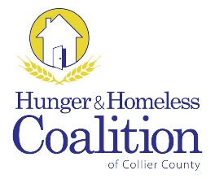
CoC Membership Meeting
August 25, 2016 – 3 pm
Catholic Charities
3174 Tamiami Trail E, Naples

Definition & Purpose
A community plan to organize and deliver housing and services to meet the specific needs of people who are at risk of or experiencing homelessness, as they move to stable housing and maximize self-sufficiency. It includes action steps to prevent & end homelessness.
Welcome & Introductions
Call to Order
Approval of Minutes
- NOFA
  - Ranking and Review Recommendations

- NEW BUSINESS
  - Programs Position Update
  - Timeline Review

- OLD BUSINESS
  - CoC Chair Vacancy

- STANDING COMMITTEE REPORT
  - Data/HMIS
  - Employment & Support Services
  - Grants
  - Housing
  - Planning
  - Youth

- ANNOUNCEMENTS

Adjourn

Next Meeting:
November 3, 2016
United Way of Collier County

