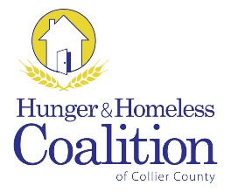
CoC Membership Meeting
July 7, 2016 – 3 pm
United Way of Collier County
9015 Strada Stell, Suite 204, Naples
Definition & Purpose
A community plan to organize and deliver housing and services to meet the specific needs of people who are at risk of or experiencing homelessness, as they move to stable housing and maximize self-sufficiency. It includes action steps to prevent & end homelessness.
Welcome & Introductions
Call to Order
Approval of Minutes
- SPECIAL PROGRAM
  - How We Serve Our Community – Ray Steadman, St. Matthew’s House
- A discussion about the programs and operations at St. Matthews House, the unique challenges facing the homeless in our community today and how we can best support this population.

- NEW BUSINESS
  - FY 2016 CoC Program Competition Timeline Overview

- OLD BUSINESS
  - CoC Chair Vacancies

- EXECUTIVE COMMITTEE REPORT

- STANDING COMMITTEE REPORT
  - Data/HMIS
  - Employment & Support Services
  - Grants
  - Housing
  - Planning
  - Youth

- ANNOUNCEMENTS

Adjourn
Next Meeting:
Thursday, September 4th 2016 at 3 pm
United Way of Collier County

