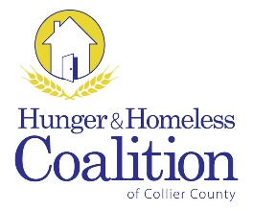
CoC Membership Meeting
May 5, 2016 – 3 pm
United Way of Collier County
9015 Strada Stell, Suite 204, Naples

Definition & Purpose
A community plan to organize and deliver housing and services to meet the specific needs of people who are at risk of or experiencing homelessness, as they move to stable housing and maximize self-sufficiency. It includes action steps to prevent & end homelessness.
Welcome & Introductions
Call to Order
Approval of Minutes
- SPECIAL PROGRAM
  - Eviction Seminar – Cathy Lucrezi, Legal Aid Collier County

- NEW BUSINESS
  - CoC Chair and Vice Chair Vacancies

- OLD BUSINESS
  - Membership
  - Coordinated Assessment

- EXECUTIVE COMMITTEE REPORT

- STANDING COMMITTEE REPORT
  - Data/HMIS
  - Employment & Support Services
  - Grants
  - Housing
  - Planning
  - Youth

- ANNOUNCEMENTS

Adjourn

Next Meeting:
Thursday, July 7th 2016 at 3 pm
United Way of Collier County

